**Service Manual**

**CONTENT**

1 Outline 3

1.1 MOBILE PHONE INTRODUCTION 3

1.2 Motherboard Components Distribution 6

2 Signal Flow And Fault Analysis 6

2.1 RF Part 6

2.1.1 Block Diagram of the RF Section 6

2.1.2 Signal Flow OF the RF Transmitting Part 7

2.1.2.1 Receiving and Transmit Path 7

2.1.2.2 Maintenance Procedures of the Transmitting Part 8

2.1.3 Signal Flow of the Receiving Part 9

2.1.3.1 Receiving Part Components 9

2.1.3.2 Maintenance Procedures of the Receiving Part 9

2.2 Baseband Part 11

2.2.1 Block Diagram of the Baseband Part 11

2.2.2 Power Management Part 12

2.2.2.1 The Whole Power Supply System 13

2.2.3 Audio Part 14

2.2.3.1 Audio CODEC Circuit 14

2.2.3.2 MIC, RECEIVER LOOP 14

2.2.3.3 HEADSET LOOP 15

2.2.4 BASEBAND FAUIT ISSUES 16

2.2.4.1 Analysis of the Keyboard Fault 17

2.2.4.2 Analysis of the Display Module Circle 18

2.2.4.3 FM Module 19

2.2.4.4 Camera Module 20

2.2.4.5 IO Interface 21

2.2.4.6 SIM Card Circuit 21

2.2.4.7 T-FLASH Card Circuit 22

2.2.4.8 BT Circuit 22

2.2.4.9 WIFI Circuit 23

2.2.4.10 GPS Circuit 24

2.2.4.11 M-sensor Circuit 24

2.2.4.12 G-sensor Circuit 25

2.2.4.13 IR-sensor Circuit 25

2.2.4.14 Gyroscope Circuit 25

# 1 Outline

## 1.1 MOBILE PHONE INTRODUCTION

|  |  |  |  |
| --- | --- | --- | --- |
| Product Hardware Introduction | | | |
| Base Chip Set | BB | MT6589W | |
| PMIC | MT6320 | |
| Transceiver | MT6167 | |
| Camera DSP/MMP | NA | |
| RFPA | SKY77590 | |
| FM | MT6628Q | |
| BT | MT6628Q | |
| Audio CODEC&PA | YD168 | |
| Memory | Samsung KMKJS000VM-B309 | |
| TP IC | GT913 | |
| Peripheral  Configuration | LCD | TM045XDHP08-00 | |
| Backlight Driver | AW9910STR | |
| CAMERA | OV8830 | |
| Memory Card | TF Card | |
| Antenna | monopole | |
| Basic Performance  Indicators | Leakage current | ≤ 150uA | |
| Standby current | ≤ 7mA | |
| Call current as maximum power | TBD | |
| Board-level power | EGSM | 32.5dBm |
| GSM850 | 32.5 dBm |
| DCS | 29.5dbm |
| PCS | 29.5dbm |
| Band1 | 23dbm |
| Band8 | 23dbm |
| Board-level receiver sensitivity | EGSM | -108dbm |
| GSM850 | -108 dbm |
| DCS | -108 dbm |
| PCS | -108 dbm |
| Band 1 | -109.5 dbm |
| Band 8 | -109.5 dbm |
| TRP | EGSM | 28.8dbm |
| GSM850 | 27.0 dbm |
| DCS | 28.0dbm |
| PCS | 28.0dbm |
| Band 1 | 20.0dbm |
| Band 8 | 20.0dbm |
| TIS | EGSM | -105dbm |
| GSM850 | -105dbm |
| DCS | -106dbm |
| PCS | -106dbm |
| Band 1 | -107dbm |
| Band 8 | -107dbm |

CPU

MT6589W

PMIC

MT6320

BATTRY

CAMERA

FM、BT、WiFi、GPS

**LCD：540*960**

KEYPAD

T-FLASH

MEMORY

MT6167

SKY77590

YD168

SPK

HP

REC

DUAL SIM CARD

MIC

**CTP**

System Block Diagram

## 1.2 Motherboard Components Distribution

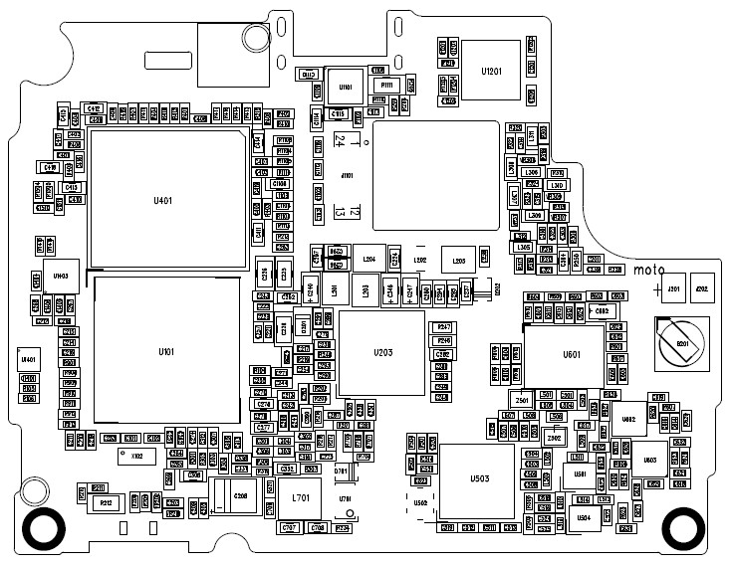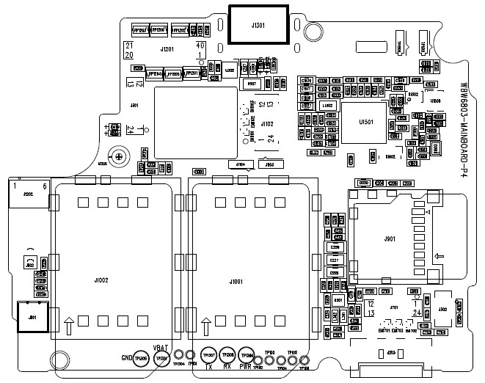

# 2 Signal Flow And Fault Analysis

## 2.1 RF Part

### 2.1.1 Block Diagram of the RF Section

ANT

PA &

Ant Switch

RF3232

Transceiver

MT6162

CPU

MT6577

GGG

RF Diagram

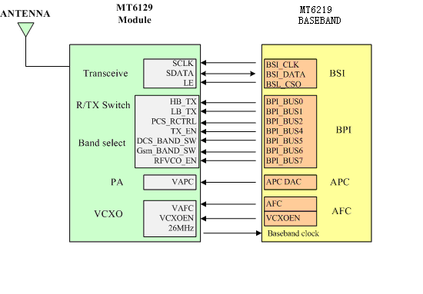 GSM RF and BB interface diagram

MT6167

MT6589W

### 2.1.2 Signal Flow OF the RF Transmitting Part

#### 2.1.2.1 Receiving and Transmit Path

Receiving

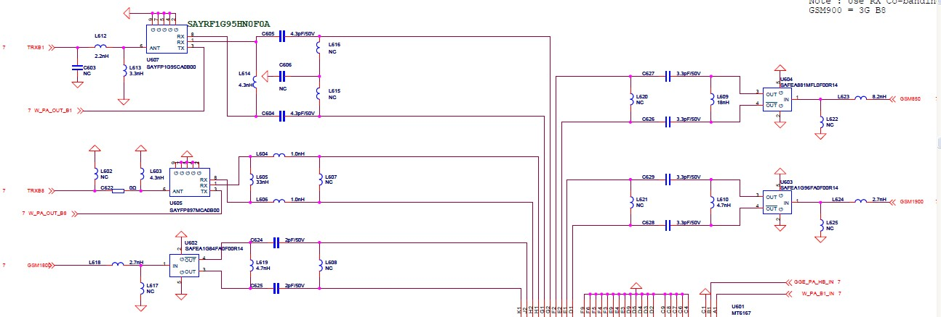

Transmit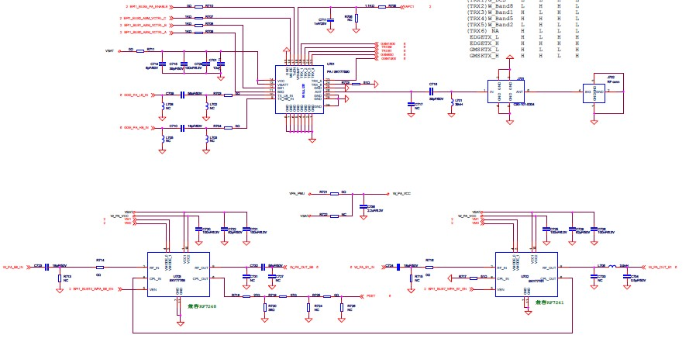

#### 2.1.2.2 Maintenance Procedures of the Transmitting Part

（NO launch） Connect the PC and the phone with maintenance line, then making the phone into the RF state with META software

Check Transceiver to see if IO signals exist.

`

Check the PA output to see if there is RF signal in the path.

Y

Check CPU

N

Check RF coaxial switch or matching network.

Y

Check the Transceiver to see if there is RF signal output.

N

CheckVBAT,PA_EN,BANDSW_DCS,VAPC 是否OK?

Replace PA

Y

Check CPU

Y

Check Transceiver if LE、SCLK/SDAT、RFVCOEN、VCXOEN have the correct signal.

N

N

N

N

Y

Replace Transceiver

### 2.1.3 Signal Flow of the Receiving Part

#### 2.1.3.1 Receiving Part Components



#### 2.1.3.2 Maintenance Procedures of the Receiving Part

No receiving

Start the META software to connect the PC and the phone，making the phone into the receiving state. Signal generator is also adjusted to the correspond CH. And signal lines connected to the phone.

的同轴开关上。

Transceiver has IQ?

Check CPU

Y

Transceiver has received signal?

？

N

Transceiver CSO,SCLK,SDATA are correct ?

Check CPU

N

Whether the voltage of the transceiver is normal? Whether 26MHZ is normal?

正常？

Y

Check the corresponding power supply and 26MHZ resulting circuit

N

Replace transceiver

Y

PA has received signal?

N

Check to see if there has signal in the matching circuit between PA and ANT

N

Check to see if there has signal in the matching circuit between PA and transceiver

Y

Y

## 2.2 Baseband Part

### 2.2.1 Block Diagram of the Baseband Part

CPU

MT6589W

PMIC

MT6320

BATTRY

CAMERA

FM、BT、WiFi、GPS

**LCD：540*960**

KEYPAD

T-FLASH

MEMORY

MT6167

SY77590

YD168

SPK

HP

REC

DUAL SIM CARD

MIC

**CTP**

### 2.2.2 Power Management Part

The power management Part use the special PMU IC : MT6320. Support 5-ways of DC-DC and 21-ways of LDO output, with AB/D, 0.7W Audio amplifier, LCD backlight driving and Lithium battery charging circuit Inside it. Which support 5 LEDs in parallel and 10 LEDs in series.

#### 2.2.2.1 The Whole Power Supply System

**DC-DC:**

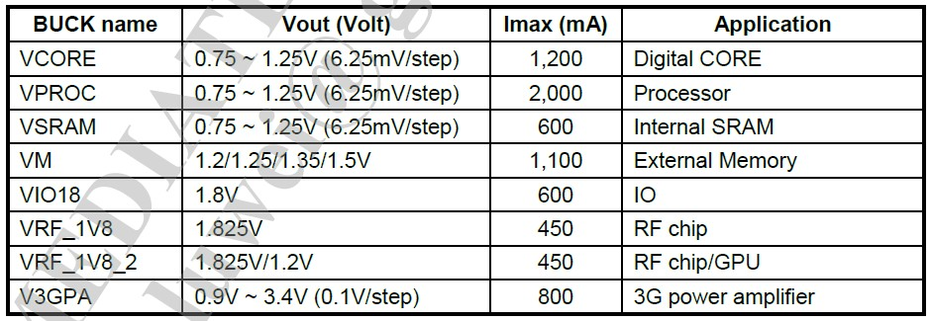

LDO

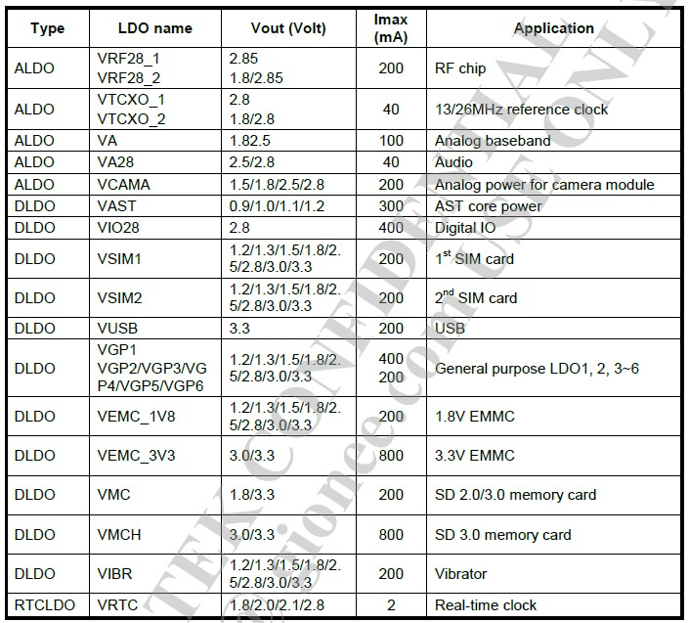

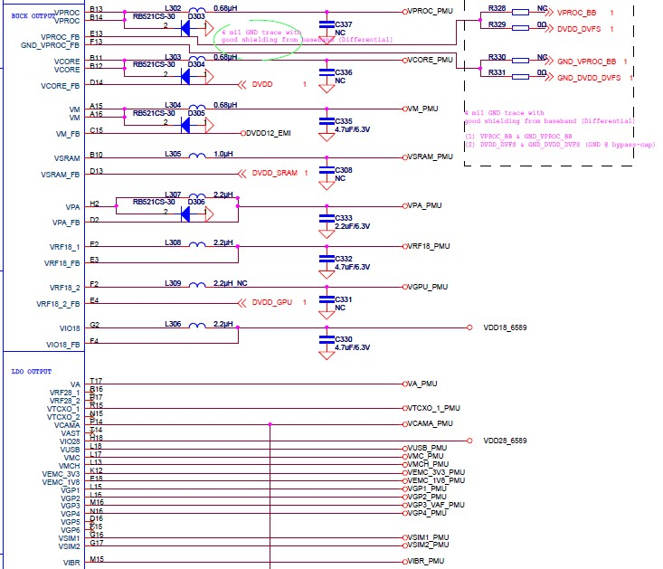

### 2.2.3 Audio Part

#### 2.2.3.1 Audio CODEC Circuit

The phone uses the chip of YD168 to driving the single speaker, which is a class D YAMAHA no-hissing amplifier.

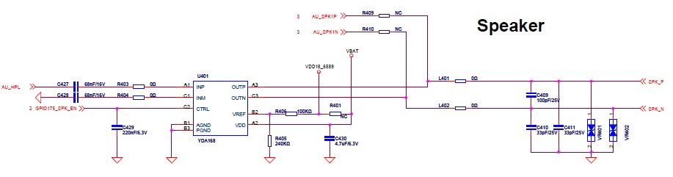

#### 2.2.3.2 MIC, RECEIVER LOOP

MIC Audio channel is shown below: This product uses the dual（OPTION）analog MIC in order to reduce noise when you use voice calling. The power supply voltage is 1.8V-3.3V. When MIC is in good condition but loop MIC has no echo, then you need to check the basic bias voltage signal of the VMC, the language signals of the RECEIVER and MIC also need to be checked.

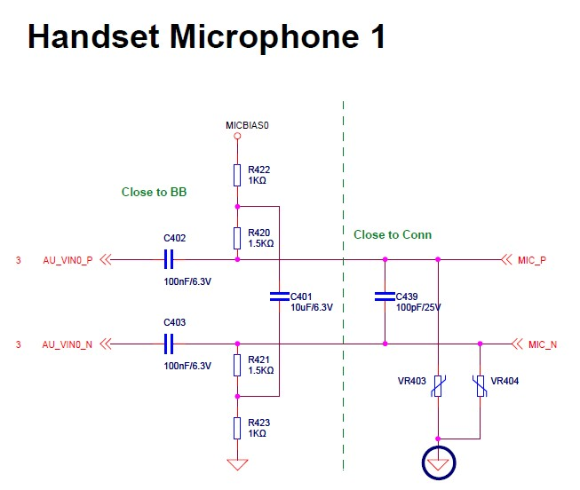

Receiver units are placed on FPC, the Motherboard MIC LOOP drive the FPC directly through J301.Filter and ESD protected network, are also placed on FPC. As shown below:

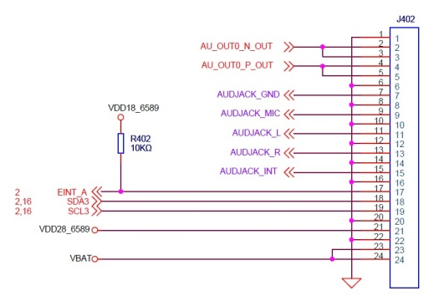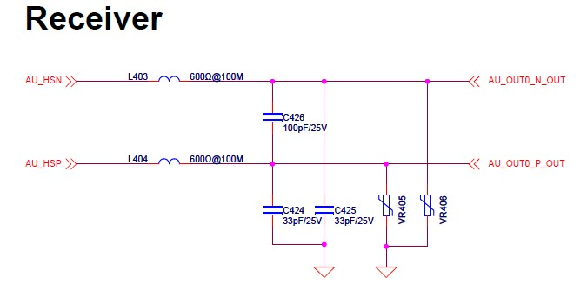

#### 2.2.3.3 HEADSET LOOP

Headset loop includes two signals: Headset speaker and MIC, simultaneously the headset uses contact devices, the headset LOOP drive the FPC directly through J301. If the headset fitting were in good condition, when the headset plug in, it appears abnormal, such as: The Headset speaker has no sound、the MIC is invalid. All this need to check the access conditions of the circuit above.

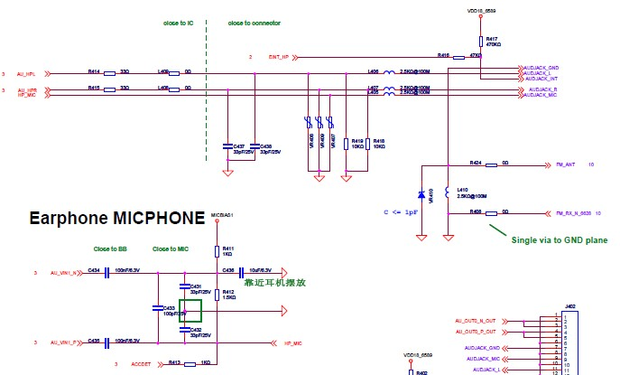

### 2.2.4 BASEBAND FAUIT ISSUES

Maintenance process of the download failure Issues:

Download Fail

Check to see if it is caused by other factors such as: configuration, download cable, power supply, software and PC

Exclude the reason of download failure caused by other factors

Yes

Check to see if the serial ports between pc and cell phone is smooth

Check if the system connector is poor soldered or damaged.

NO

NO

Check the resistance, capacitance and the EDC devices between the system connector and the CPU.

NO

Connect the download cable then observe the Ammeter to see if it shows high current（The normal current generally about 30mA）

Yes

Quickly disconnect the connection, and gently touch the chip to see if it is hot. If not, then focus point using the multi-meter to measure the short circuit.

Yes

Check the power manager and open the LDO to see if the voltage supply is normal and whether there is power supply circuit open.

Little or no current

Check VCORE、VDD、VADD、VTCXO、VRTC、VMEM、Measure the clock signal of 26MHZ、32KHZ.

Current normal but download fail

Check CPU and NAND FLASH、SDRAM to see if they are OK and the LDO is normal.

#### 2.2.4.1 Analysis of the Keyboard Fault

This board includes 3 side-buttons. All the keyboard circuits use the scanning method to detect except the power button, volume up and down. The scanning signal will be triggered when a button is pressed,, then the corresponding row and column will be detected, the function of the key can be identified according to the software definition.

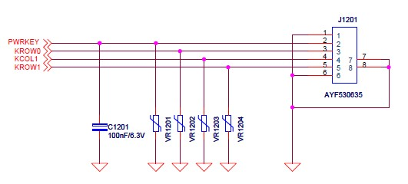

* 1. **The cell phone can power on ，but all the keys are invalid.**

In general, this situation is caused by some key short-circuit, the equivalent of a long pressing this button.

At this point ,you should analyze the following first：

⑴ Check peripheral TVS of the button to see if they are short-circuit.

⑵ Then ,check the connector to see whether it is short-circuit when it is welded.

* 1. **Failure of a single button**

This situation needs to check whether the beneath of the DOME key is dirty. If the problem is still existed, you have to check whether the circuit is open.

* 1. **Failure of a few buttons**

This situation is usually caused by a short-circuit row or column. Checking the interface circuit to see if it has open weld phenomena and detect the disconnected phenomena of the resistance.

#### 2.2.4.2 Analysis of the Display Module Circle

Display module use the 4.5"IPS LCD, which including 2 pairs MIPI differential bus mode. All of commend and data go through the MIPI differential bus mode except the reset signal.

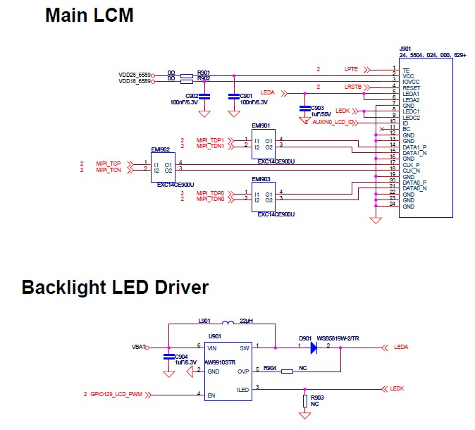

For the screen problem you should first use the alternative method to search out whether the problem is in the motherboard or the LCD. Focus on examining the LCM connector and EMI filter welding.. The backlight signal is completed by the LED driver chip RT9614. Generally, measure the input voltage VBAT　and the enable control signal.

#### 2.2.4.3 FM Module

The WIFI Circle is based on chip MT6628Q, comes with FM module and transmitter function, also with both analog and digital audio channels choose from. The RF part supply short antenna design and long antenna design.

The FM interface Circle as shown below:

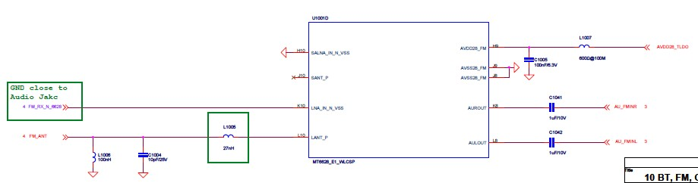

FM use the headphone ground as the antenna，therefore the headset ground and the motherboard ground have1000@100M magnetic beads to isolate FM(80M~108M)signals.

#### 2.2.4.4 Camera Module

The module uses 8 million pixel AF camera as the main camera, 0.3 million pixel camera as the sub camera. Through the connector and the baseband chip (the main camera series EMI devices) directly connected.

The Camera Interface Circuit as show below:

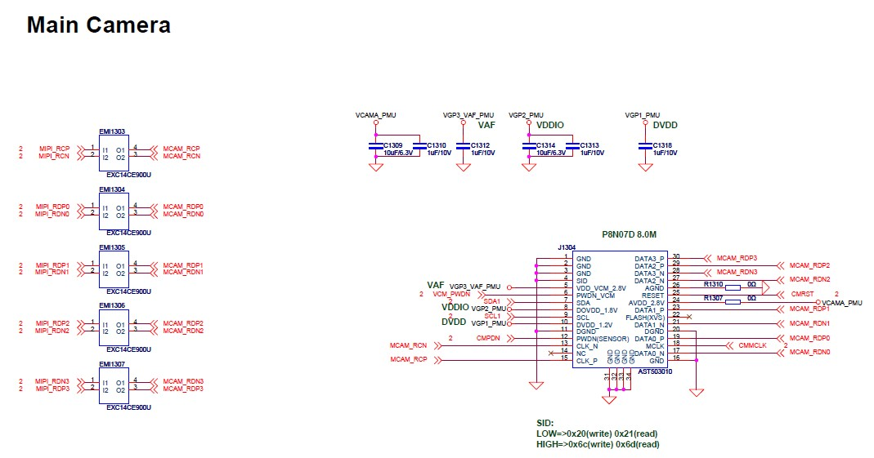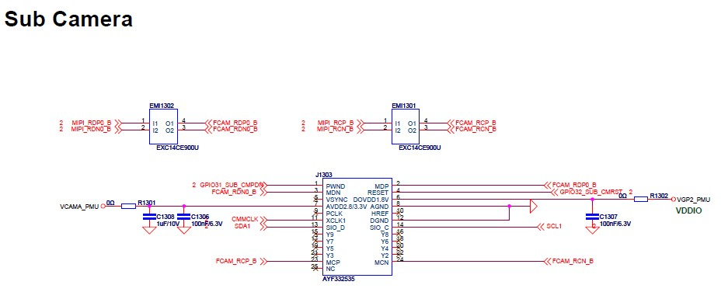

The Camera Power Supply Circuit

The VCAM_IOPMU supply 1.8V to Camera IO interface voltage, VCAMA_PMU supply 2.8V analog voltage.

#### 2.2.4.5 IO Interface

IO applies 5pin standard interface，which realize the functions of USB, charging and download.

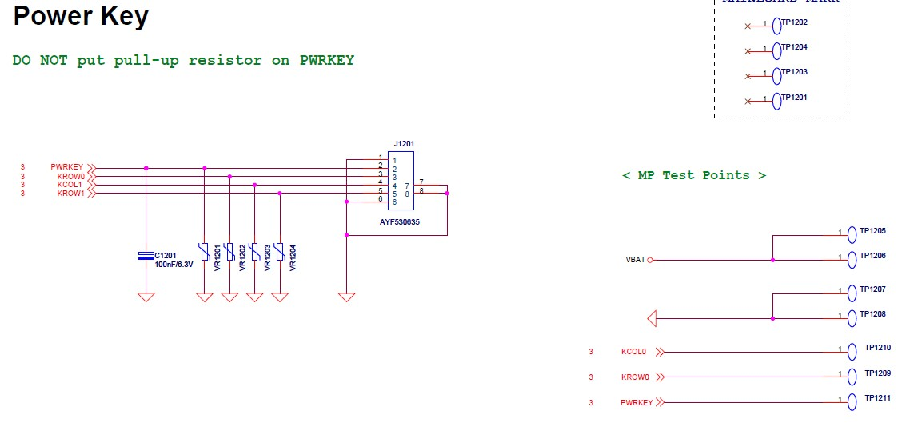

#### 2.2.4.6 SIM Card Circuit

Switch of dual SIM cards is integrated into baseband, which supports dual SIM Card function, SIM1 support GSM/WCDMA Card, SIM2 support only GSM Card.. As show below:

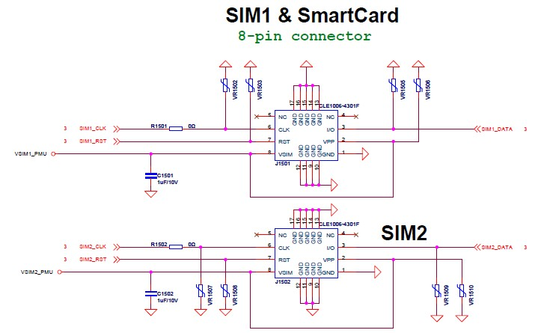

#### 2.2.4.7 T-FLASH Card Circuit

The T-FLASH Card Circle support data exchange between Phone and PC. The Circuit have four serial data transmission lines（MCODA0,MCODA1,MCODA2,MCODA3） and state detection(MCOCMD),CLOCK(MCOCK),as the show below:

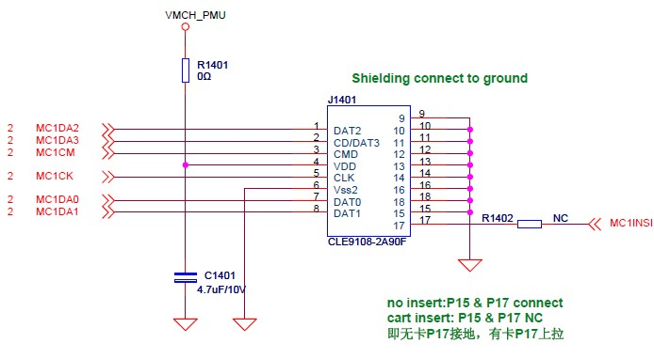

#### 2.2.4.8 BT Circuit

The Bluetooth function is one part of the MT6628Q .The BT Circuit include baseband, RF unit, UART2 unit, PCM interface system configuration, and also.

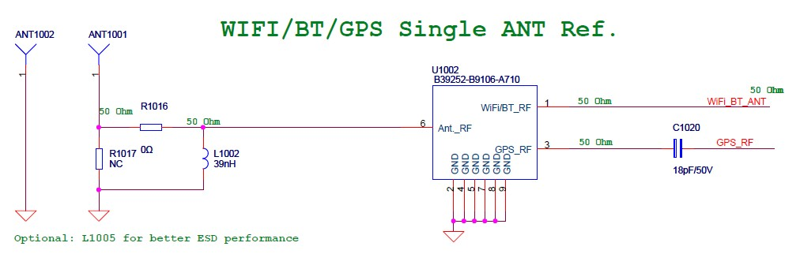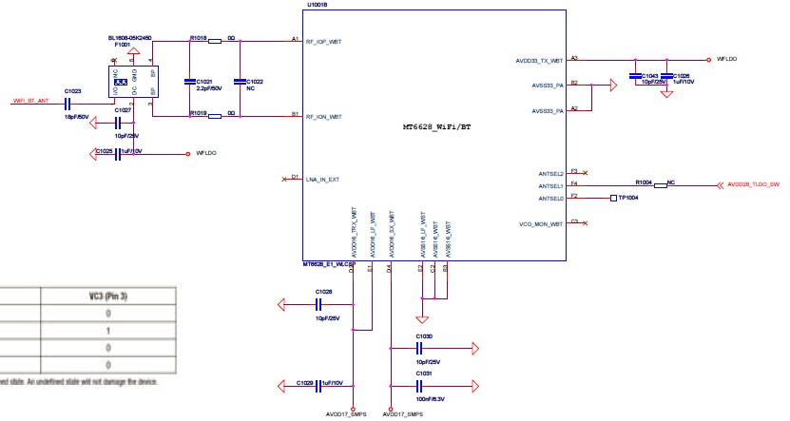

#### 2.2.4.9 WIFI Circuit

The WIFI Circuit integrated in MTK6628Q, The WIFI Circuit includes baseband, RF unit, power, SDIO interface system configuration. It supports dual-band (2.4G and 5G), following 802.11d/h/k agreement, supports safety format is WFA, WPA/WPA2, WPS2.0, WAPI.

The WIFI’S RF interface is connected with external antenna. The ANT is transmitting or receiving signals to communicate with WIFI equipment.

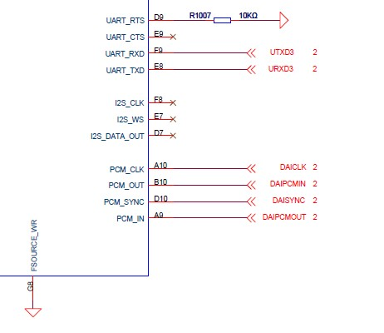

#### 2.2.4.10 GPS Circuit

The GPS Circuit integrated in MTK6628Q, It includes baseband, RF unit, power, UART interface system configuration. Its sensitivity supports 165dBm, supports AGPS.

The GPS’S RF interface is connected with external antenna. The ANT is receiving GPS satellite signal to achieve positioning. GPS and BT share the same ANT. We switch GPS signal by the switch U1505, then through a narrowband filter U1603 (OPTION) into GPS chip.

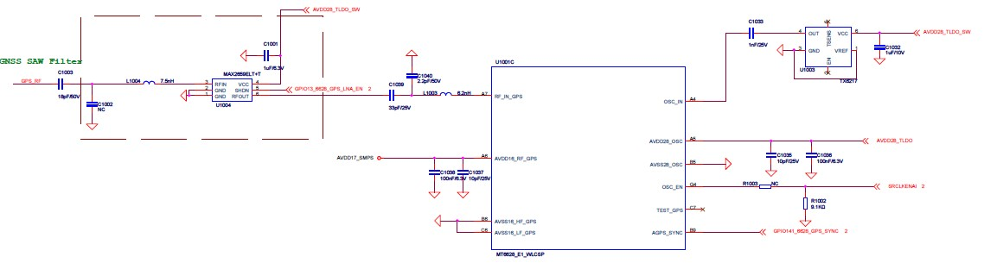

#### 2.2.4.11 M-sensor Circuit

M-SENSOR is a electronic compass, it supports X, Y, Z three-axis orientation sensor. M-SENSOR uses I2C to connect CPU interface, in order to transmit directives and data.

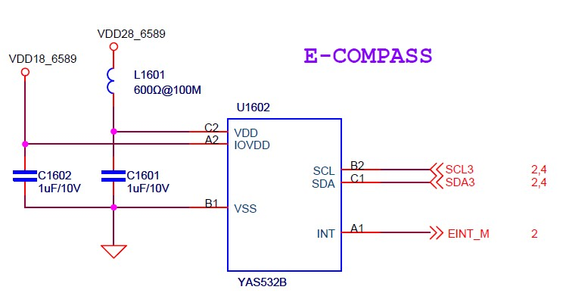

#### 2.2.4.12 G-sensor Circuit

G-SENSOR is a sensor of acceleration due to gravity. It supports X, Y, Z three-axis orientation sensor. M-SENSOR uses I2C to connect CPU interface, in order to transmit directives and data.

#### **26**2.2.4.13 IR-sensor Circuit

IR-SENSOR is light &distance sensor. It induces current phone the environment in which of the brightness and Perceived distance of the human face in the phone calling and the phone. IR-SENSOR uses I2C to connect CPU interface, in order to transmit directives and data, also we need an INT give CPU a trigger signal.

 2.2.4.14 Gyroscope Circuit

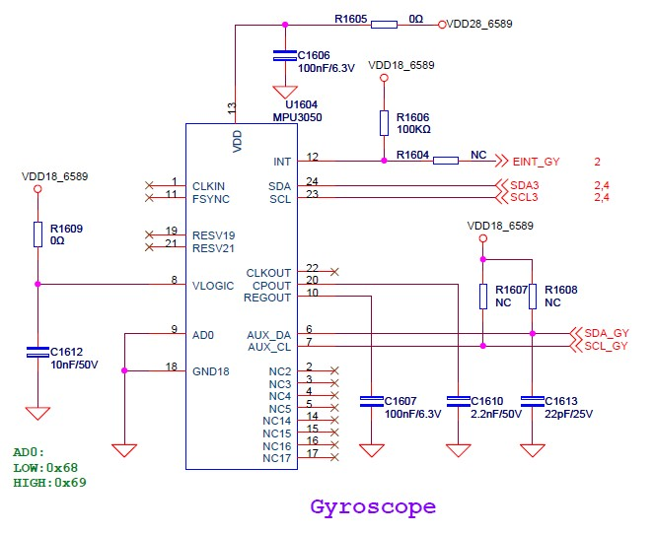

# 3. Disassembly and assembly service Tools

